Manipal University Jaipur

Department of Chemical Engineering

CE 1708- Economics and Project Management

IV YEAR, VII SEMESTER, 2019

MINI-PROJECT FINAL REPORT



INSTRUCTOR(S):

Dr. Gaurav Kataria

SUBMITTED BY : AKSHAY SRIVASTAVA

: SHUBHAM PARUTHI

: VINAMRATA VERMA

Contents

1 Introduction 2

1.1 Ethyl Benzene Reaction System 2

1.2 Methods of Producing Ethyl Benzene 3

2 Process Simulation 7

2.1 HYSYS Simulation Fluid Property Package 7

2.3 HYSYS Process Flow Diagram 7

2.4 Simulation Sheet (PFD) 9

3 Market Survey 10

3.1 UOP Process 10

4 Costs 10

4.1 Equipment Costs 10

4.2 Capital Costs 12

4.3 Direct Operating Costs 12

4.4 Profitability 12

# 1 Introduction

The reaction of benzene with ethylene produces ethyl benzene and by-product di-ethyl benzene. Ethyl benzene is an intermediate in the production of styrene. There are multiple technologies in current practice in the styrene industry. The fundamental differences are related to the reaction phase and vessel system. In the following sections, several methods of ethyl benzene production are explored to determine which technologies offer the best combination of profitability and inherent safety.

## 1.1 Ethyl Benzene Reaction System

The proposed plant design involves creating ethyl benzene from the raw components of benzene and ethylene. The chemical reaction to create ethyl benzene is:

C6H6 + C2H4 → C6H5C2H5 (1.1)

Eq.(1.1) for the reaction of benzene and ethylene to form EB is accompanied by five side reactions. Three of them are shown in Eq. (1.2), (1.3), and (1.4).

|  |  |
| --- | --- |
| C6H6 + 2C2H4 → C6H4(C2H5)2 | (1.2) |
| C6H5C2H5 + C2H4 → C6H4(C2H5)2 | (1.3) |
| C6H6 + C6H4 (C2H5)2 ⥨ 2C6H5C2H5 | (1.4) |

The reaction illustrated in Eq. (1.2) and (⥨1.3) produces an undesired product, DEB.

Proper use of LeChatelier’s Principle can force the equilibrium reaction described by Eq. (1.4) to yield as much desired product (EB) as possible. Eq. (1.5) and (1.6) show two further side reactions, but are negligible for simulation purposes.

|  |  |
| --- | --- |
| C6H5C2H5 + C2H4 → CH3C6H4C3H7 | (1.5) |
| C6H5C2H5 + C2H4 → (CH3)2C6H3C2H5 | (1.6) |

The kinetics for these two reactions were not found to be documented in literature. However it has been shown that the reaction extents for both reactions are negligible when simulating the process.1 As such, Eq. (1.1)-(1.4) shall be used for design in HYSYS. Several process designs can be implemented to favour the production of EB.

Several methods for creating ethyl benzene are discussed in the proceeding section.

## 1.2 Methods of Producing Ethyl Benzene

Most production methods of creating ethyl benzene have approximately 95 mol% conversion.1 The three methods discussed in this report include the creation of ethyl benzene in the gas-phase reaction (Mobil/Badger), in the liquid phase using an AlCl3 acid catalyst, and a liquid phase reaction in fixed bed reactors using a zeolite catalyst.

1.2.1 Liquid Phase Reaction Using Zeolite Catalyst in a Fixed Bed

The liquid phase reaction uses a zeolite catalyst which does not require special material for reactor internals, piping, or in other parts of the process. In addition, the zeolite catalyst is not as harmful to the environment which saves in disposal costs.

This process, like the preceding AlCl3 and Alcar process, requires an alkylator and a transalkylator. In addition, the operating temperature and pressures are similar to that of the AlCl3 process. The B/E alkylator feed ratios range from 1.5-2.0 on a molar basis. Since temperatures and pressures are not extreme and B/E ratios are relatively low, there are large savings available in operational costs when compared to the Mobil/Badger process. Further, since the catalyst is contained in fixed beds there are reduced operational costs when compared to the AlCl3 and Alcar process because the catalyst does not have to be continuously removed from the process using a filter and washing.

3

2

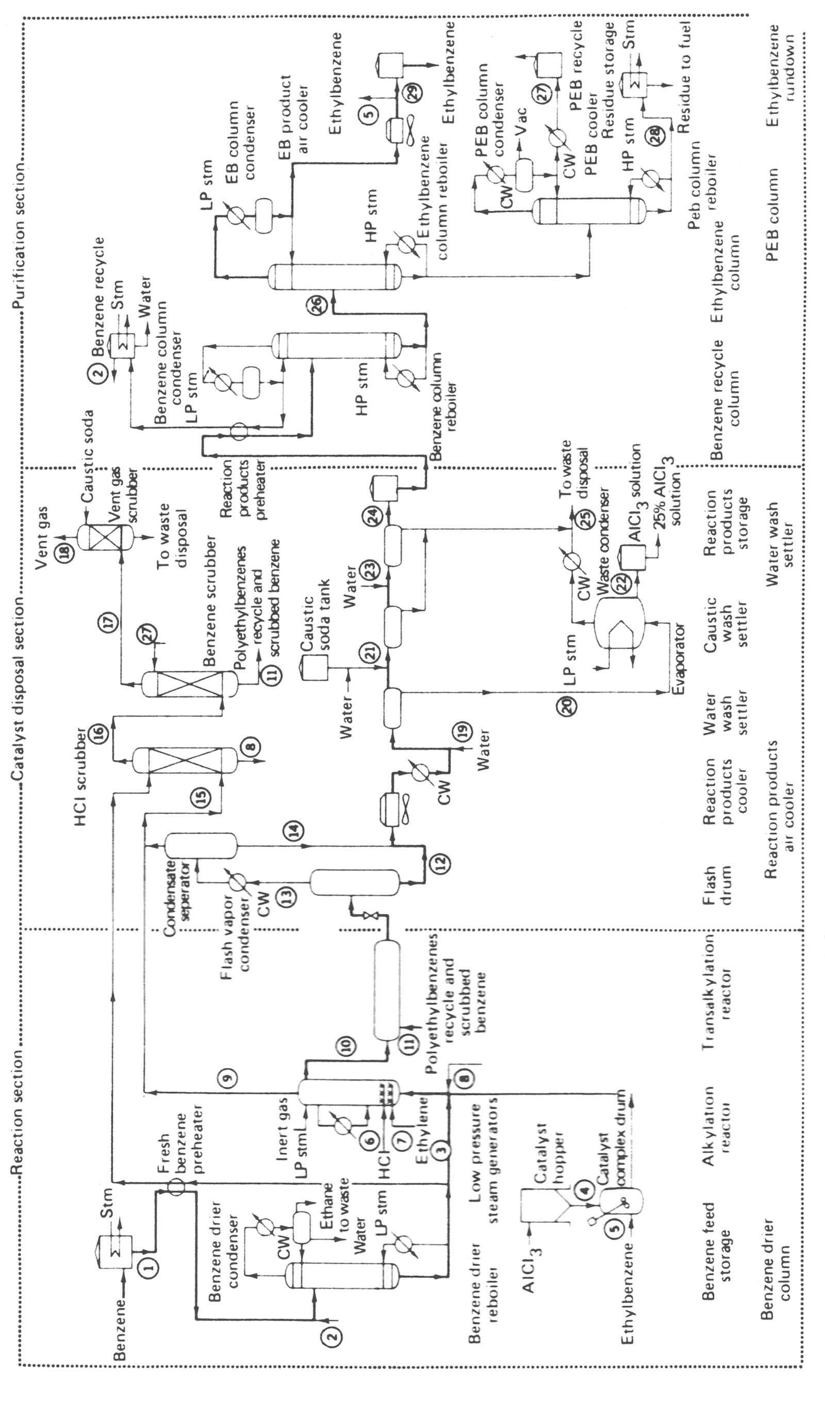

:

Figure 1: Production of EB using AlCl3

Figure 2: Production of EB using the Alcar process

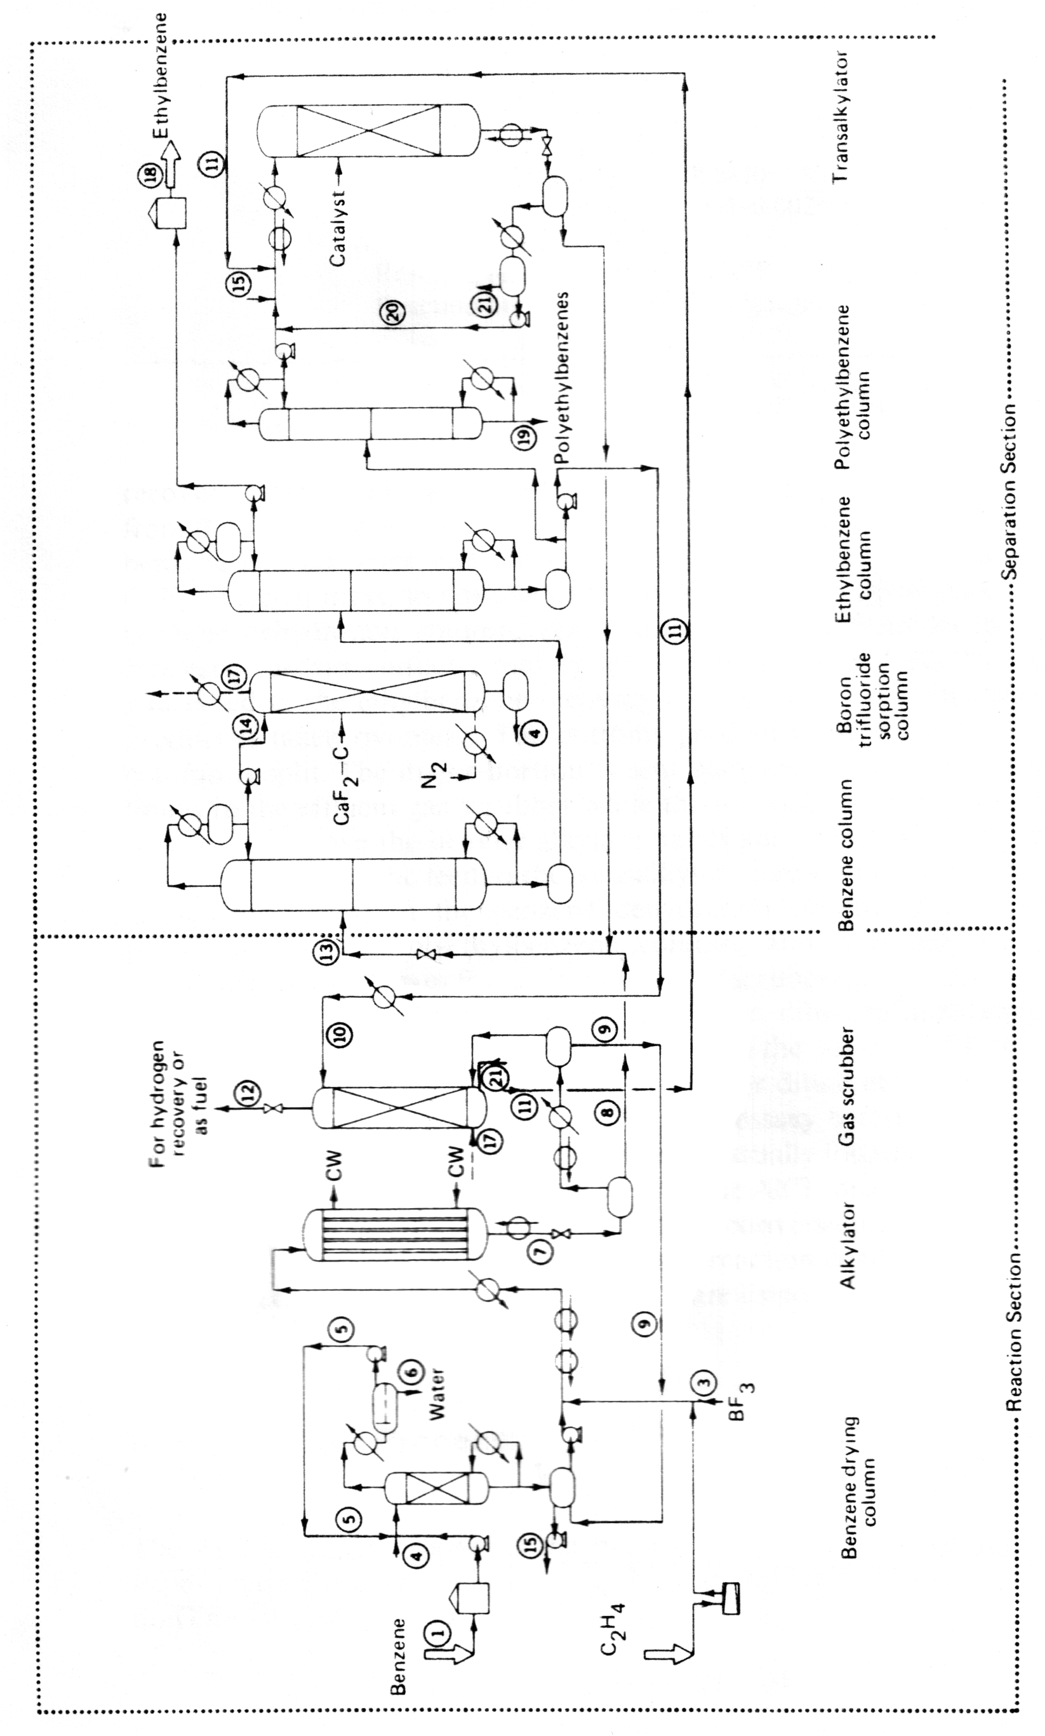

The most positive aspect of the EBOne process is that catalyst life is claimed to be at least five years for the alkylator and the transalkylator when using the EBZ-500™ and EBZ-100™ as the fixed bed catalyst, respectively. Also, these catalysts may be regenerated for at least three cycles. Therefore, they constitute a more economical alternative to conventional catalyst. Further savings are realized since shutdowns are less frequent to change out the catalyst in the fixed beds of the reactors. A diagram of the EBOne process is shown below in Figure 1-5.

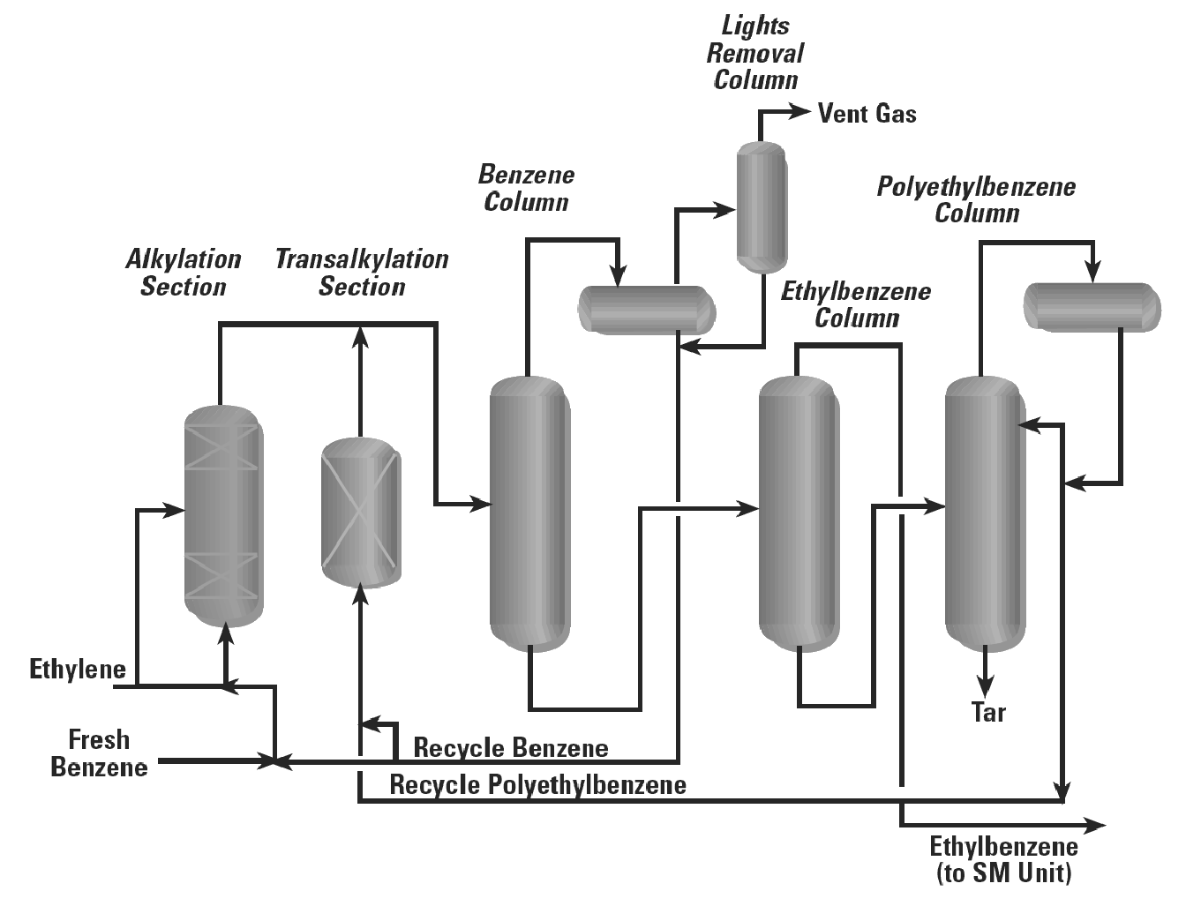

Figure 3: EBOne process.3

As Figure 1-5 shows, the main reaction takes place in the “Alkylation Section” in the presence of the EBZ-500™ catalyst in fixed beds. The ethylene and benzene react to form the product ethyl benzene and other unwanted products. The top product of this reactor flows to the “Benzene Column” where the excess benzene is removed from the product stream and then sent back as recycle with “Fresh Benzene”. The remaining gas is then sent to a “Lights Removal Column” where any un-reacted ethylene is sent to a flaring system. Any un-separated benzene is also combined with the recycled benzene stream.

The bottoms of the “Benzene Column” are sent to the midsection of the “Ethyl Benzene Column”. The ethyl benzene product is separated from the other unwanted products as distillate and then sent to storage. The bottoms of the “Ethyl Benzene Column” are sent to the mid section of the “Poly-ethyl Benzene Column”. The distillate of this column is condensed and combined with some recycle benzene and then sent to the “Transalkylation Section”. In the “Transalkylation Section” the side reaction (DEB and TEB) products are reacted in the presence of the EBZ-100™ catalyst in fixed beds to form more ethyl benzene. The top product of “Transalkylation Section” is then combined with the top product of the “Alkylation Section”, where it repeats the process loop. The bottom product of the “Poly-ethyl Benzene Column” is mostly a viscous tar material which is disposed of as a waste material.

# 2 Process Simulation

## 2.1 HYSYS Simulation Fluid Property Package

The Peng-Robinson property fluid package was used for this simulation. It utilizes the Peng-Robinson (PR) equation of state model which can be seen in the HYSYS help manual. It was chosen because the PR model gives good results for non-polar systems, and has a wide range of materials that can be used for accurate results. All the components used in the production of EB are either non-polar or contain very weak dipole moments. It was also noted that HYSYS contained all the necessary interaction parameters for the PR EOS model, which sharply improves accuracy.

## 2.3 HYSYS Process Flow Diagram

Figure 2-1 shows the HYSYS process flow diagram in its entirety. There are 14 main process operations contained in five sections of the plant. Table 2-1 summarizes the PFD labels of these operations with descriptions of the equipment and the section of the plant in which they are contained. Table 2-2 shows a summary of each of the five sections of the plant.

Table 2-1: Operation-section key

|  |  |  |
| --- | --- | --- |
| PFD Label | Operation Description | Plant Section |
| P-1 | Fresh benzene feed pump to Alkylator | Section 1 |
| E-1 | Alkylation Feed Cooling System | Section 1 |
| P-2 | C-1 Recycle Pump | Section 1 |
| R-1-1A/R-1-2A | Train One Alkylation Section | Section 2 |
| R-2-1A/R-2-2A | Train Two Alkylation Section | Section 2 |
| R-1-1B/R-1-2B | Train One Equilibrium Reactor | Section 2 |
| R-2-1B/R-2-2B | Train Two Equilibrium Reactor | Section 2 |
| VLV-100 | Alkylation Effluent Pressure Reducer | Section 2 |
| E-2 | R-1 Assembly Cooling system | Section 3 |
| C-1 | Benzene Separation Column | Section 3 |
| C-2 | EB Separation Column | Section 3 |
| C-3 | Flash Drum | Section 3 |
| E-3 | C-2 Cooling system | Section 4 |
| R-3-1A | Transalkylation Alkylator | Section 4 |
| R-3-1B | Transalkylation Equilibrium Reactor | Section 4 |

Table 2-2: Plant section description.

|  |  |
| --- | --- |
| Section  Number | Brief Description |
| Section 1 | Feed preparation section of the plant. Its purpose is to prepare the feed components for the reactions in Section 2. |
| Section 2 | Alkylation section of the plant which is divided into two trains of reactors. The purpose of this section is to form ethyl benzene from ethylene and benzene raw components. It contains four real reactors, a reducing valve and a cooling system. |
| Section 3 | Benzene and ethyl benzene separation section of the plant. It contains two distillation columns and a flash drum. |
| Section 4 | Transalkylation section of the plant. Converts some of the diethyl benzene to ethyl benzene using C-1 benzene recycle |

A detailed description of each section is discussed in the following sections. Operating conditions, performance, design specifications are discussed in further detail.

## 2.4 Simulation Sheet (PFD)

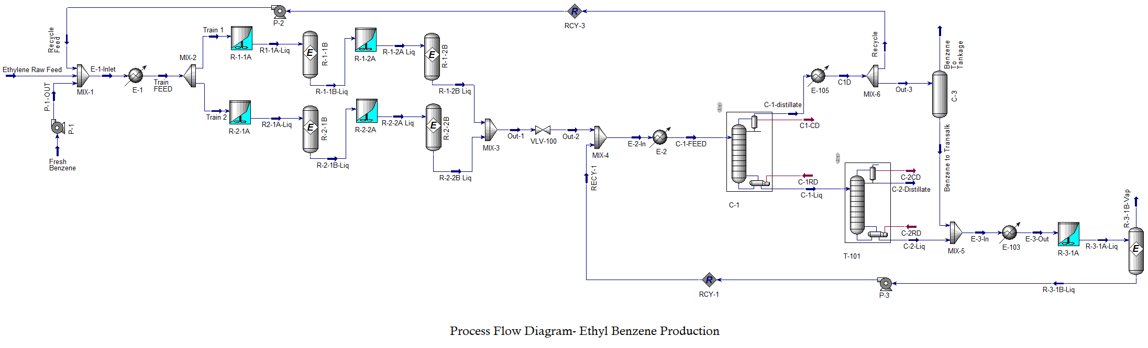

# 3 Market Survey

Over 99.9% of the ethyl benzene produced in the world is used in the manufacture of styrene. Therefore, the demand for ethyl benzene is determined primarily by styrene production.16 EB is also used in the manufacturing of industrial solvents and, on occasion, in the production of diethyl benzene, acetophenone and ethyl anthrax-quinone.

## 3.1 UOP Process

In 1996, UOP and Lummus successfully commercialized a new zeolitic EBZ500 catalyst for the alkylation of benzene with ethylene to produce EB.19 The first commercial plant to use the liquid-phase process began production in 1990 by the Nippon Styrene Monomer Corporation (Japan). The plant used the UOC-4120 zeolite catalyst manufactured by UOP for both the alkylation and transalkylation reactors. Two subsequent plants were constructed in Japan in 1994, this time, using the newly developed EBZ-100 transalkylation catalyst. By 1997, full-scale plants were using EBZ-500 (the catalyst proposed for the current project) in South-East Asia, Japan, and Germany.

# 4 Costs

The current NPV of the plant is US$ 7 million. A new process technology is considered a medium level of risk.14 The rate of return (ROR) was determined to be 27%.

## 4.1 Equipment Costs

Equipment costs have been calculated for the current plant design based on available data from Peters and Timmerhaus.14 Estimated purchasing and installation costs are shown in Table 4-1. For economical reasons, carbon steel was selected for equipment construction. Carbon steel has suitable corrosion resistance for the chemicals used in the production of EB.14

Total purchasing costs in 2004 amount to US$ 3.6 million and total installation costs are US$ 2.3 million. The two distillation columns (C-1 and C-2) account for the largest portion (60%) of the equipment costs.

Table 4-1: Equipment costs (all equipment is carbon steel). EB = 156,000 tonne/yr

|  |  |  |  |
| --- | --- | --- | --- |
| Equipment | Description | Purchase  Cost,  US $ | Install  Cost,  US $ |
| CSTR (R-1) | 35 m3; CS jacketed; 300 psia | 121,800 | 54,800 |
| CSTR Motor (R-1) | 35 m3 | 2,600 | 1,200 |
| CSTR (R-1) | 35 m3; CS jacketed; 300 psia | 121,800 | 54,800 |
| CSTR Motor (R-1) | 35 m3 | 2,600 | 1,200 |
| CSTR (R-1) | 35 m3; CS jacketed; 300 psia | 121,800 | 54,800 |
| CSTR Motor (R-1) | 35 m3 | 2,600 | 1,200 |
| Pump (P-1) | 16 m3/h | 5,600 | 2,400 |
| Pump Motor (P-1) | 10 kW | 1,300 | 600 |
| Pump (P-2) | 68 m3/h | 9,300 | 4,000 |
| Pump Motor (P-2) | 39 kW | 2,600 | 1,100 |
| Pump (P-3) | 26 m3/h | 6,600 | 2,800 |
| Pump Motor (P-3) | 2 kW | 500 | 200 |
| Separator | 3.3 m3 | 33,400 | 15,000 |
| Dist Col (C-1) | 3.4 m diameter; 27 trays; 16.3 m height, = 0.6 | 1,051,200 | 788,400 |
| Condenser (C-1) | 59E6 kJ/h; 212 m2 | 104,800 | 78,600 |
| Reboiler (C-1) | 59E6 kJ/h;  713 m2 | 245,100 | 110,300 |
| Dist Col (C-2) | 2.3 m diameter; 33 trays; 20.3 m height, = 0.6 | 977,300 | 733,000 |
| Condenser (C-2) | 18E6 kJ/h;  242 m2 | 115,100 | 86,300 |
| Reboiler (C-2) | 18E6 kJ/h;  368 m2 | 154,100 | 69,400 |
| Totals (2018) |  | 3,576,100 | 2,328,100 |

## 4.2 Capital Costs

The capital costs for the preliminary plant design are shown in Table 4-2. The capital cost includes equipment, materials, labour, indirect construction costs, engineering, and contingencies. The total capital investment was estimated at US$ 23.7 million or $US 150/tonne-yr.

Table 4-2: Capital costs (EB = 156,000 tonne/yr).

|  |  |  |
| --- | --- | --- |
| Item | Factor | Cost, US $ |
| Equipment | - | 3,576,100 |
| Installation | - | 2,328,100 |
| Piping | 0.68 (E) | 2,431,748 |
| Electrical | 0.11 (E) | 393,371 |
| Fixed Capita Investment | | 8,729,319 |
| Working Capital | 0.89 (E) | 3,182,729 |
| Total Capital Investment | | 11,912,048 |

## 4.3 Direct Operating Costs

The projected direct operating costs are summarized in Table 4-3 (showing raw materials, utility and power cost). Since catalyst is purchased once every five years, an annual equivalent rate was calculated. Approximately 96% of the annual cost is associated with the raw material; 83% of which is benzene. The indirect operating costs, or fixed costs, are represented in Table 4-4. The projected total operating costs (direct and indirect) for the EB plant is estimated at US$ 160.2 million, or US$ 1,030/tonne.

Table 4-3: Direct operating costs (EB = 156,000 tonne/yr).

|  |  |  |  |
| --- | --- | --- | --- |
| Item | Rate | Basis | Cost , US $/yr |
| Benzene | 14,200 kg/yr | 1.05 | 129,717,000 |
| Ethylene | 4,770 kg/yr | 0.484 | 20,081,900 |
| Water | 633,000kg/yr | $ 8E-6/kg (200C) | 44,100 |
| Catalyst | 43,500 kg/5yr | 0.05 | 12,400 |
| Labour |  |  | 2,175,000 |
| Power | 50 kW | $0.055/kwh | 24,000 |
| Total Operating cost | | | 35,309,100 |

Table 4-4: After Tax Cash Flow for the Plant Design

|  |  |  |  |
| --- | --- | --- | --- |
| **Year** | **0** | **1-9** | **10** |
| **Gross Revenue** | **-** | 174720000 | 175077610 |
| **(-)Operating Cost** | - | 152054400 | 152054400 |
| **(-) Depreciation** | - | 321849 | 321849 |
| **Taxable Income** | - | 22343751 | 22701361 |
| **Income tax (40%)** | - | 8937500.4 | 9080544.4 |
| **Gross Income** | - | 13406250.6 | 13620817 |
| **(+) Depreciation** | - | 321849 | 321849 |
| **(-) Total Capital Cost** | 11912048 | - | - |
| **After Tax Cash Flow** | -11912048 | 13728099.6 | 13942666 |

## 4.4 Profitability

The current plant design is economically viable. Figure 4-1 shows the expected rate of return as a function of the selling price of ethyl benzene at the current EB selling price of $1.12/kg.71 Note that all other variables (e.g. purchasing price of raw material) are held constant in the calculation. Figure 4-1 indicates that EB can be sold for $1.02/kg to break even and $1.09/kg to meet the MARR of 20% based on the current production.

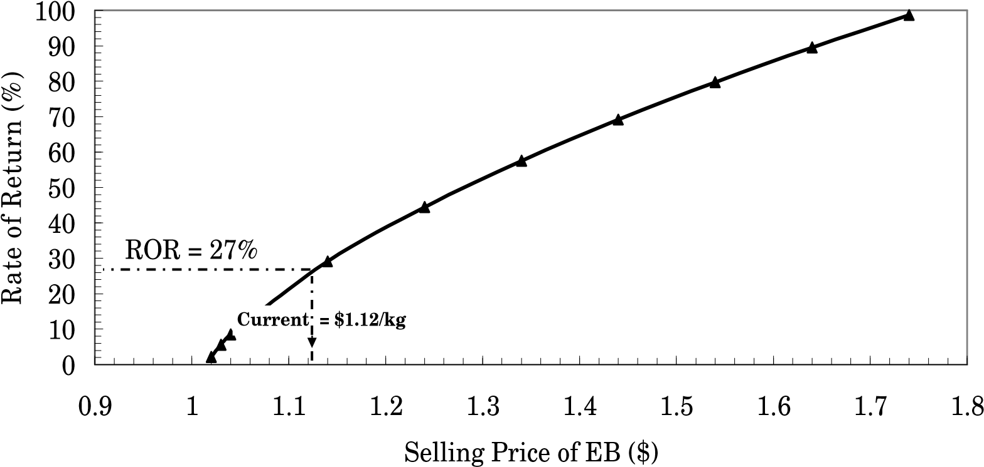

Figure 4-1: Rate of return as a function of selling price.

Figure 4-2 shows the relationship of total capital cost (TCI) in $/tonne-year and total operating cost (TOC) in $/tonne as a function of EB production. At the current production rate of 156,000 tonne/yr, the TCI and TOC are approximately $US 150/tonne-year and $US 1,030/tonne, respectively.

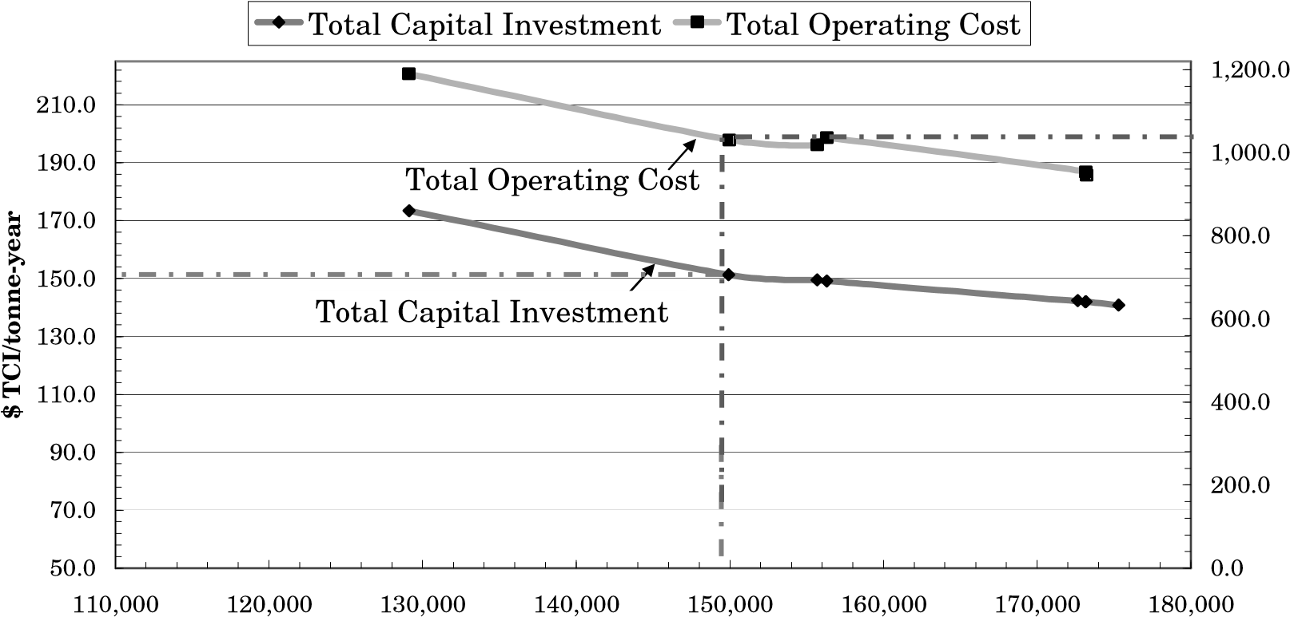

$ TOC/tonne

EB Production (tonne/yr)

Figure 4-2: Relationship of total capital cost and total operating cost as a function of EB production.

Figure 4-3 shows the relationship between ROR and ethyl benzene production for various selling prices of EB.

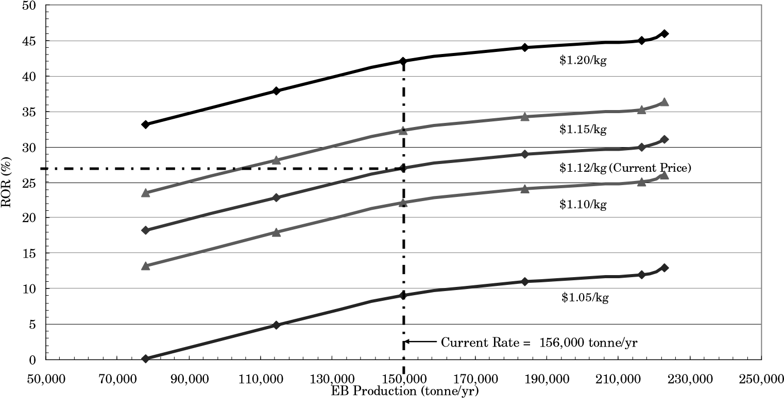

Figure 4-3: Relationship of ROR as a function of EB production for various selling prices of EB (current = $US 1.12/kg).